

Chalique nail studio information system

HELP manual

Table of Contents

Getting Started 1

Logging in 1

Making a booking 2

Edit booking 3

Cancel a booking 3

Finish a booking 4

Managing Employees 4

Managing Clients 6

# Getting Started

# Logging in

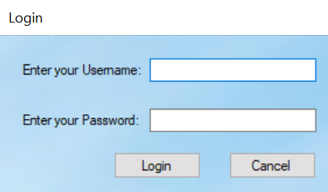Enter your credentials and click *login* to gain access to the main program. Please note: After 3 failed attempts, an email will be sent to the owner notifying them of the failed login. In addition to the sent email, the program will be terminated.

# Making a booking

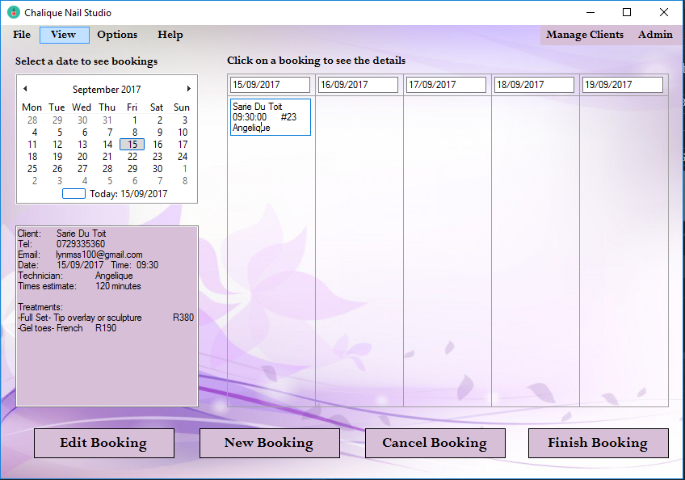

Click the *New Booking* button to open the new booking form

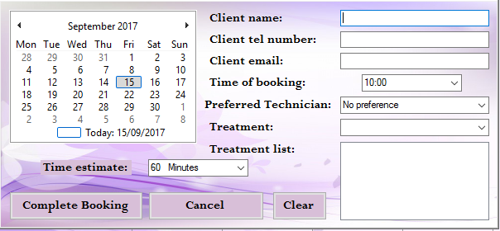Enter the clients’ credentials as well as the details of the booking. Note that several treatments can be added using the dropdown list provided.

* *Complete booking* completes the initial booking and adds it to the booking columns in the previous form.
* *Cancel booking* cancels the booking and returns to the previous form.
* *Clear* removes all the added details from form.

# Edit booking

Select a booking you wish to edit. When booking is selected, the remaining buttons on the form will appear.

* Select the Edit booking (with a booking selected from the bookings columns) to open the new booking form with all of the current details of the booking.
* Change the details of the booking you wish to edit.
* Click Complete Booking to update details and return to the previous form.

# Cancel a booking

If you wish to cancel a booking:

* Select the booking which you want to delete.
* Click the *Cancel* Booking to delete booking.
* A message will be displayed to confirm that you wish to cancel the booking.

# Finish a booking

Click *finish booking* to proceed to the finish booking form.

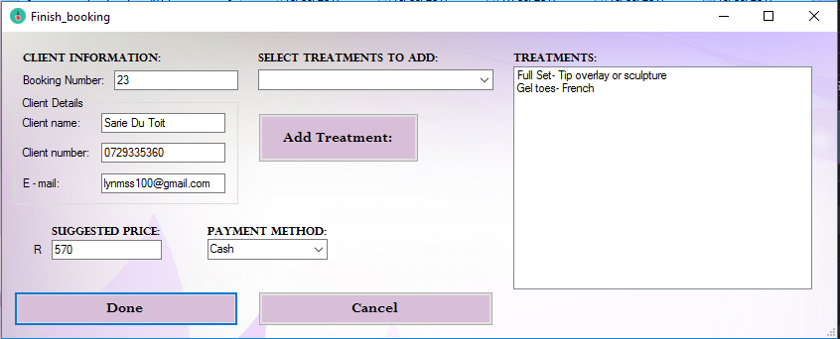

* Confirm clients’ details and select payment method.
* (Optional) Select any additional treatments that were added during the treatment and click *Add Treatment* to add it to the treatments list.
* Click *Done* to confirm payment and return to previous form.
* Click *Cancel* to cancel payment.

# Managing Employees

Under Options on the Main form, Select *Employee Options* to add or remove employees from the system. Note that administrative login is required in order to access the Employee Options form.

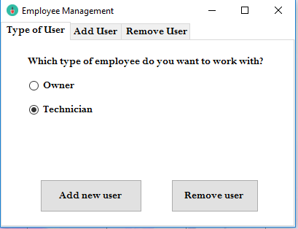

Select which type of employee to add or remove and click *Add new user/Remove user*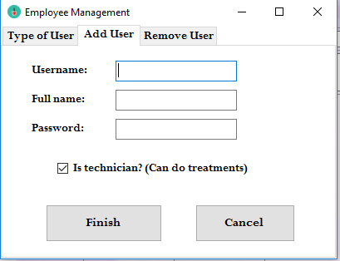

To add Employee:

* Enter credentials of new employee.
* Tick whether the person is a technician or not
* Click *Finish* to add new user and return to previous form.
* Click *Cancel* to return to previous form without adding new employee.

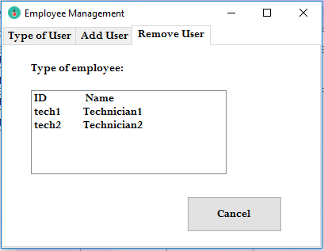

To remove Employee:

* Select employee to remove (*Remove* will display when employee is selected)
* Click *Remove* to delete selected employee.
* Click *Cancel* to return to previous form.

# Managing Clients

Click *Manage Clients* on the main form to display the Client Management form.

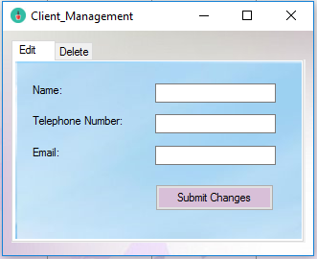

To Edit Clients:

* Enter Client full name which will be edited.
* Enter NEW client telephone number and Email. (Last step on next page)
* Click *Submit Changes* to update client details.

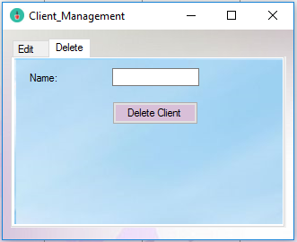

To delete Clients:

* Select the Delete tab.
* Enter Client name which will be deleted.
* Click *Delete Client* to permanently delete Client.